**HOMEWORK 2 : Saiabhinav Chekka :** [**schekka@iu.edu**](mailto:schekka@iu.edu) **: Spring 2024**

#### **Question 1 (2 points)**

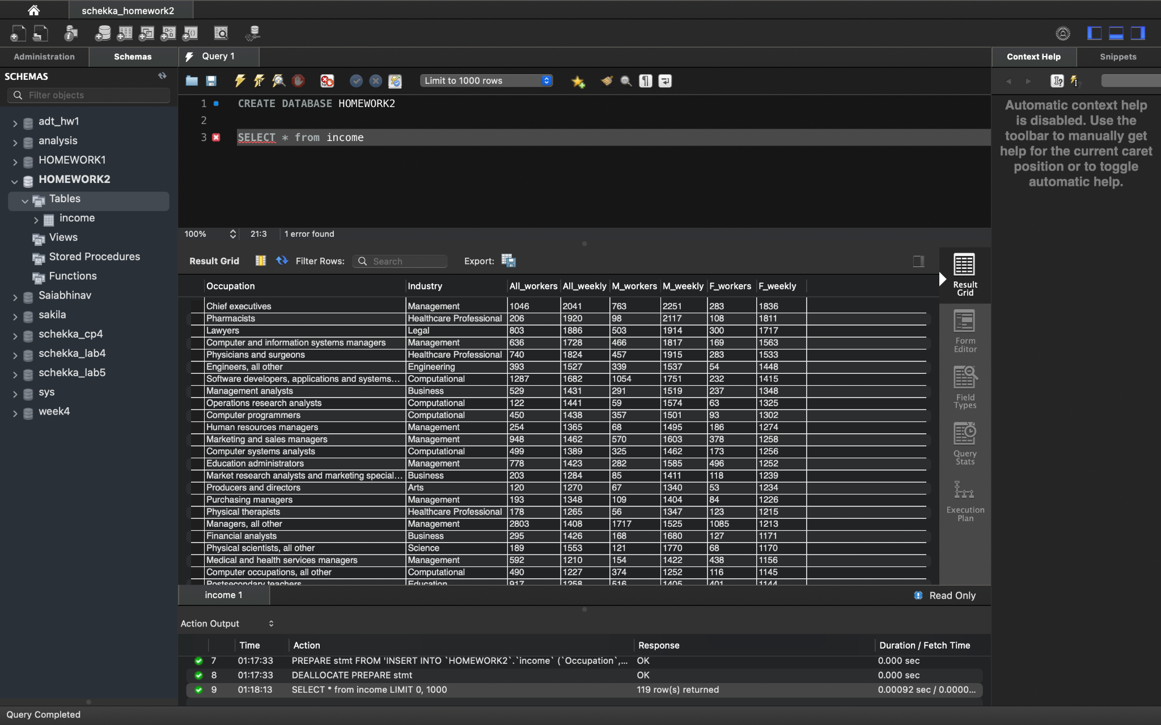

**-- Question 2**

**ALTER TABLE income**

**ADD COLUMN occupation_id INT NOT NULL AUTO_INCREMENT PRIMARY KEY;**

**-- Question 3**

**-- Write a query to display distinct industries from the income table**

**SELECT DISTINCT Industry FROM income;**

**CREATE TABLE IF NOT EXISTS INDUSTRY (**

**Industry_ID INT AUTO_INCREMENT,**

**Industry_Name VARCHAR(255) NOT NULL UNIQUE,**

**Average_Revenue DECIMAL(15,2),**

**Profit_Margin_Percentage DECIMAL(5,2),**

**Average_Age INT,**

**Education_Required VARCHAR(255),**

**PRIMARY KEY (Industry_ID)**

**);**

#### **Question 4 (3 points)**

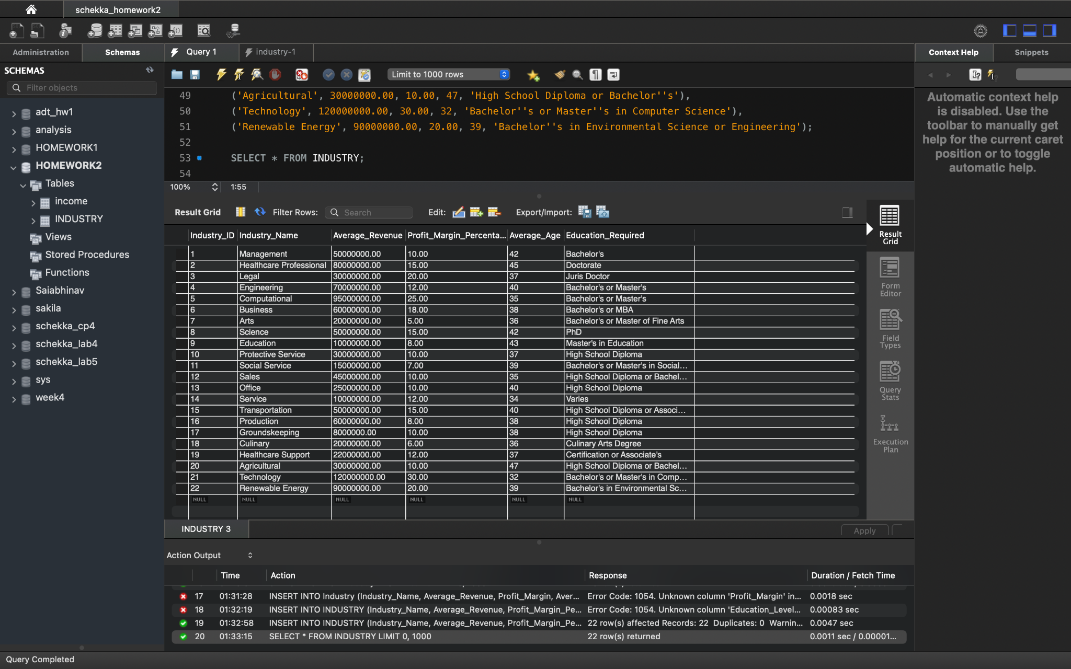

**Question 5**

**1. Perform join between the ‘income’ and the ‘industry’ table on the industry_name field. Ensure that all the columns from the income and the industry table are retrieved (2 points)**

**SELECT \***

**FROM income**

**JOIN INDUSTRY**

**ON income.Industry = INDUSTRY.Industry_Name;**

**2. Create a view Industry_Income using the above join between the two tables created above to showcase the average of weekly income across all the industries (use the All_Weekly column). Group the results by industry_name from the industry table (4 points)**

**CREATE VIEW Industry_Income AS**

**SELECT INDUSTRY.Industry_Name, AVG(income.All_Weekly) AS Average_Weekly_Income**

**FROM income**

**JOIN industry ON income.Industry = INDUSTRY.Industry_Name**

**GROUP BY INDUSTRY.Industry_Name;**

**3. Perform one Exploratory Data Analysis on the view Industry_Income (2 points)**

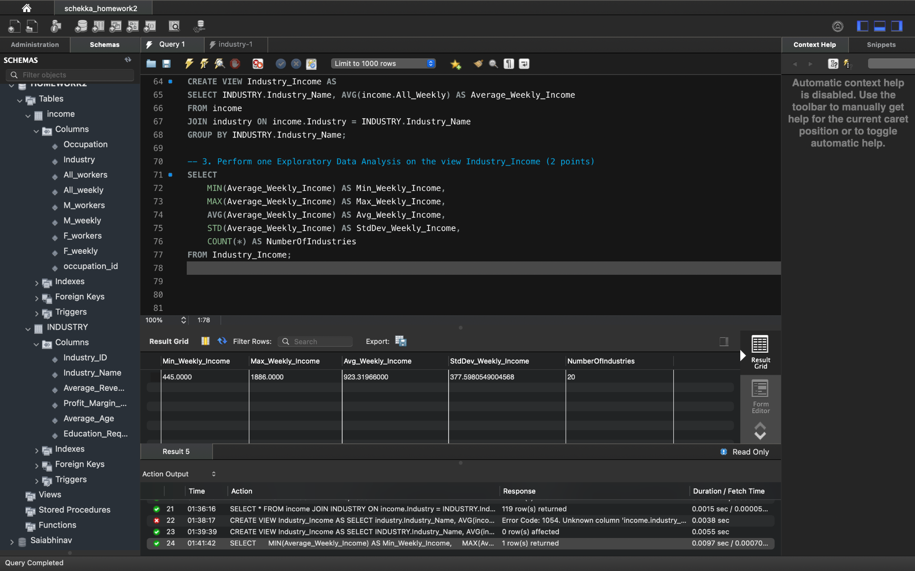

**4. Similarly, perform join on the ‘income’ and ‘industry’ tables such that all the matches from the ‘industry’ table are retrieved (2 points)**

**SELECT \***

**FROM INDUSTRY**

**LEFT JOIN income**

**ON INDUSTRY.Industry_Name = income.Industry;**

### **Part 2: Database Design (25pts)**

#### **Question 1 : If you design a database schema for income data, which attribute(s) would you choose as a primary key? And why?**

The primary key should uniquely identify each record in the database. I would also make sure that the value of the primary key doesn't change. I would choose the primary key based on columns that are guaranteed to be unique and also the columns that are not null for every record.

**Uniqueness Check :** We need to ensure that the column we are considering for a primary key is unique across all records.

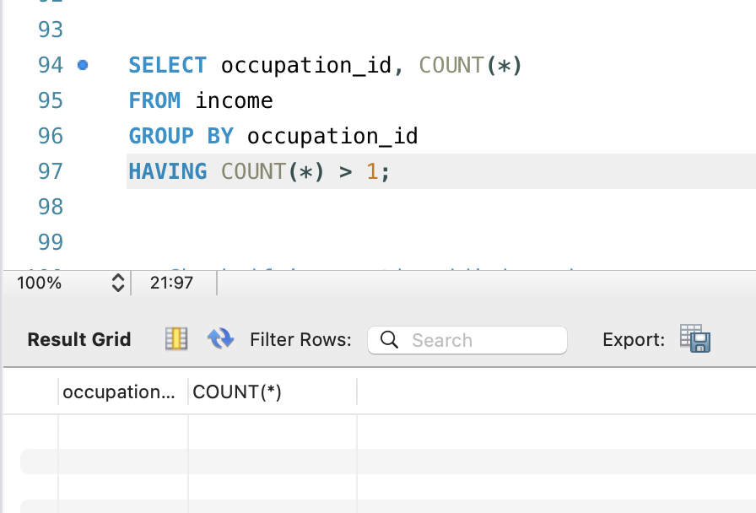

**Non-null Check:** A primary key must not be null.

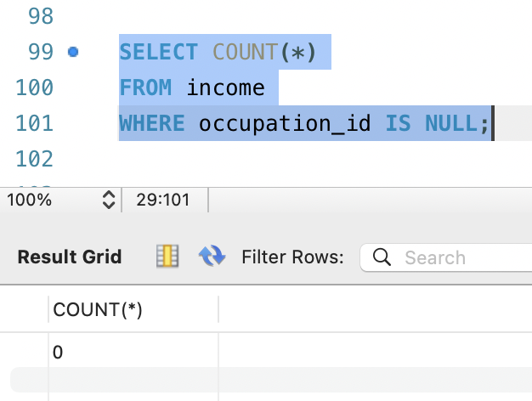

**Data Type Consistency:**

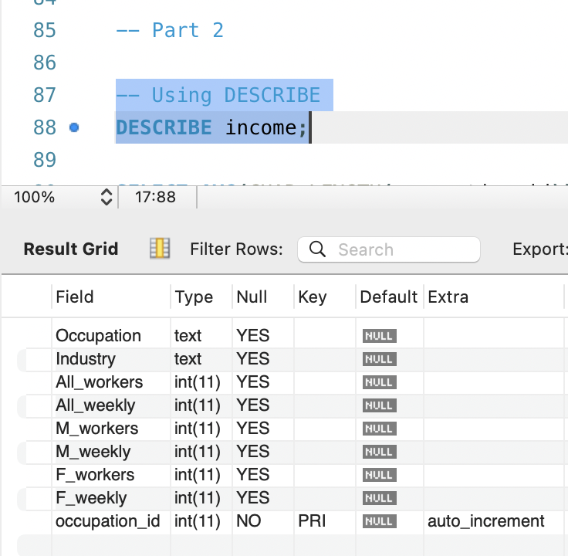

Having ‘occupation_id’ as a primary key, Using an integer as a primary key generally provides fast lookup performance because integer comparisons are usually faster than text comparisons. Also, It simplifies the foreign key relationships with other tables since we only need to store a single integer to reference an occupation.

Considering all the above reasons, it seems appropriate to keep ‘occupation_id’ as the primary key for the income table.

#### **Question 2**

**You decided to redesign the income database and split it into several tables. What changes would you implement?**

In order to divide the ‘income’ database into multiple tables and redesign it, I would normally use normalization methods to arrange the data into logical groups so that each group represents a subset of the entire. This reduces duplication(I mean redundancy), avoids difficult queries, and enhances data integrity.

#### **1. Demographics Table:**

* individual_id (Primary Key): Uniquely identifies each individual.
* years: The individual's age.
* education_level: The highest education level attained by the individual.
* marital_status: The individual's marital status.
* relationship_status: Details about the individual's relationship status.
* ethnicity: The individual's ethnic background.
* gender: The individual's gender.

#### **2. Sector Table:**

* sector_id (Primary Key): Unique identifier for each sector.
* sector_title: The name of the sector.
* sector_avg_revenue: Average revenue within the sector.
* sector_profit_ratio: The profit ratio typical within the sector.
* workforce_avg_age: Average age of employees in the sector.
* required_qualification: Typical educational qualifications required in the sector.

#### **3. Earnings Table:**

* earnings_id (Primary Key): Unique identifier for each earnings record.
* individual_id (Foreign Key): References individual_id from the Demographics Table.
* sector_id (Foreign Key): References sector_id from the Sector Table.
* work_title: The title of the work or position held by the individual.
* gain: Capital gain associated with the individual.
* loss: Capital loss associated with the individual.
* weekly_hours: The number of hours the individual works per week.
* country_of_origin: The country where the individual was born or originates from.
* earnings_bracket: Classification of the individual's income bracket.

### **Considerations for Revised Design:**

* The Demographics Table centralizes personal attributes of individuals, which are likely to remain constant regardless of employment changes.
* The Sector Table focuses on attributes that describe various industry sectors, emphasizing revenue and workforce characteristics.
* The Earnings Table connects individuals to their respective sectors and details their income-related data, acting as a relationship table.
* This approach ensures that each table is focused on a singular aspect (person, industry sector, earnings), which simplifies updates and queries.

### **Part 3: Implement Part 2 Design (25pts)**

#### **Question 1 (3 points)**

**List the tables** that you plan to create after redesigning the above income database

#### **Demographics Table, Sector Table, Earning Table**

#### **Question 2 and Question 3**

-- DDL for Demographics Table

CREATE TABLE Demographics (

individual_id INT AUTO_INCREMENT PRIMARY KEY,

years INT NOT NULL CHECK (years >= 0),

education_level VARCHAR(255) NOT NULL,

marital_status VARCHAR(255) NOT NULL,

relationship_status VARCHAR(255),

ethnicity VARCHAR(255),

gender VARCHAR(50) NOT NULL,

UNIQUE (individual_id)

);

-- DDL for Sector Table

CREATE TABLE Sector (

sector_id INT AUTO_INCREMENT PRIMARY KEY,

sector_title VARCHAR(255) NOT NULL,

sector_avg_revenue DECIMAL(19, 4) CHECK (sector_avg_revenue >= 0),

sector_profit_ratio DECIMAL(5, 2) CHECK (sector_profit_ratio >= 0),

workforce_avg_age INT CHECK (workforce_avg_age >= 0),

required_qualification VARCHAR(255),

UNIQUE (sector_id)

);

-- DDL for Earnings Table

CREATE TABLE Earnings (

earnings_id INT AUTO_INCREMENT PRIMARY KEY,

individual_id INT NOT NULL,

sector_id INT NOT NULL,

work_title VARCHAR(255) NOT NULL,

gain DECIMAL(19, 4) DEFAULT 0,

loss DECIMAL(19, 4) DEFAULT 0,

weekly_hours INT CHECK (weekly_hours >= 0 AND weekly_hours <= 168),

country_of_origin VARCHAR(255),

earnings_bracket VARCHAR(255) NOT NULL,

FOREIGN KEY (individual_id) REFERENCES Demographics(individual_id),

FOREIGN KEY (sector_id) REFERENCES Sector(sector_id),

UNIQUE (earnings_id)

);

-- Indexes for the Earnings Table

CREATE INDEX idx_individual_id ON Earnings(individual_id);

CREATE INDEX idx_sector_id ON Earnings(sector_id);

-- Query to get the DDL of an existing table

SHOW CREATE TABLE HOMEWORK2.Demographics;

SHOW CREATE TABLE HOMEWORK2.Earnings;

SHOW CREATE TABLE HOMEWORK2.Sector;

**Question 4 (2 points) :** Insert **at least 2 records** in each table that you created above and paste your queries below

-- Insert records into the Demographics Table

INSERT INTO Demographics (years, education_level, marital_status, relationship_status, ethnicity, gender)

VALUES (30, 'Bachelors', 'Married', 'Husband', 'White', 'Male'),

(25, 'Masters', 'Single', 'Not_in_family', 'Black', 'Female');

-- Insert records into the Sector Table

INSERT INTO Sector (sector_title, sector_avg_revenue, sector_profit_ratio, workforce_avg_age, required_qualification)

VALUES ('Technology', 500000.00, 20.00, 32, 'Bachelors'),

('Healthcare', 300000.00, 15.00, 40, 'Doctorate');

-- Insert records into the Earnings Table

INSERT INTO Earnings (individual_id, sector_id, work_title, gain, loss, weekly_hours, country_of_origin, earnings_bracket)

VALUES (1, 1, 'Software Developer', 10000.00, 0.00, 40, 'USA', '>50K'),

(2, 2, 'Physician', 20000.00, 0.00, 50, 'USA', '>50K');

#### **Question 5 (5 points) :** Display the data of each table (add screenshots).

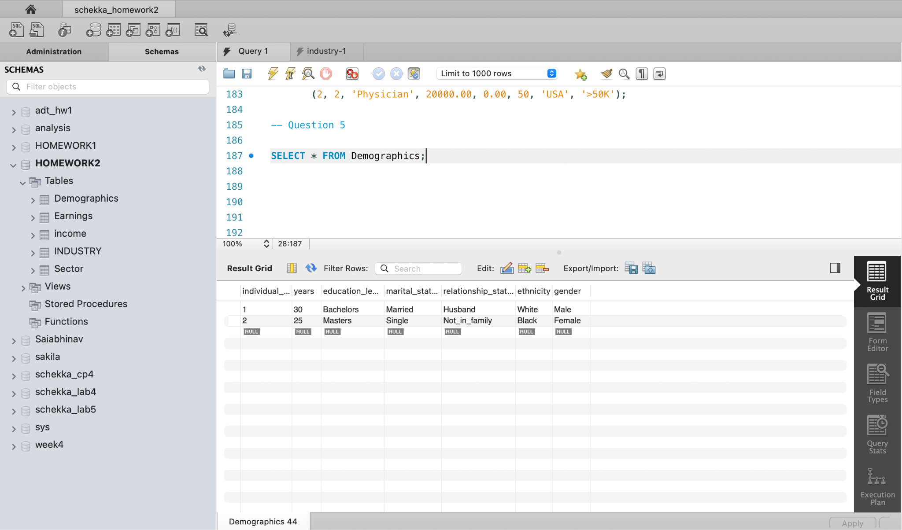

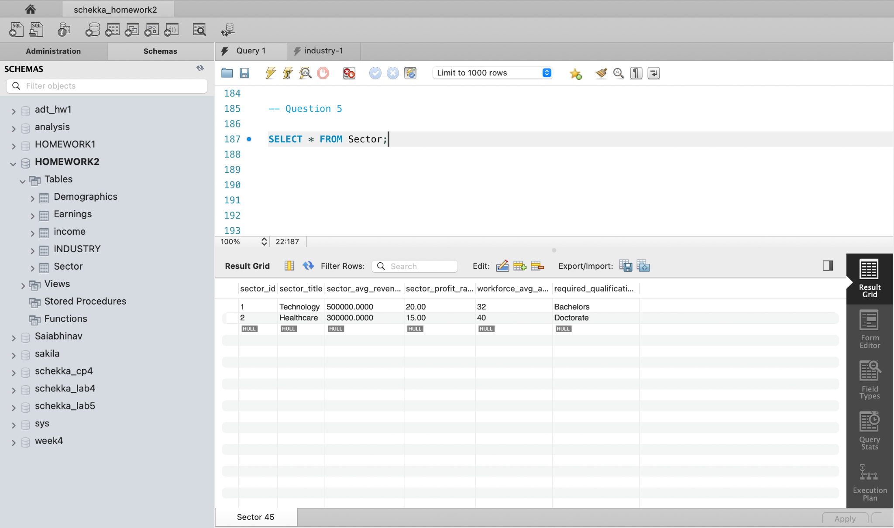

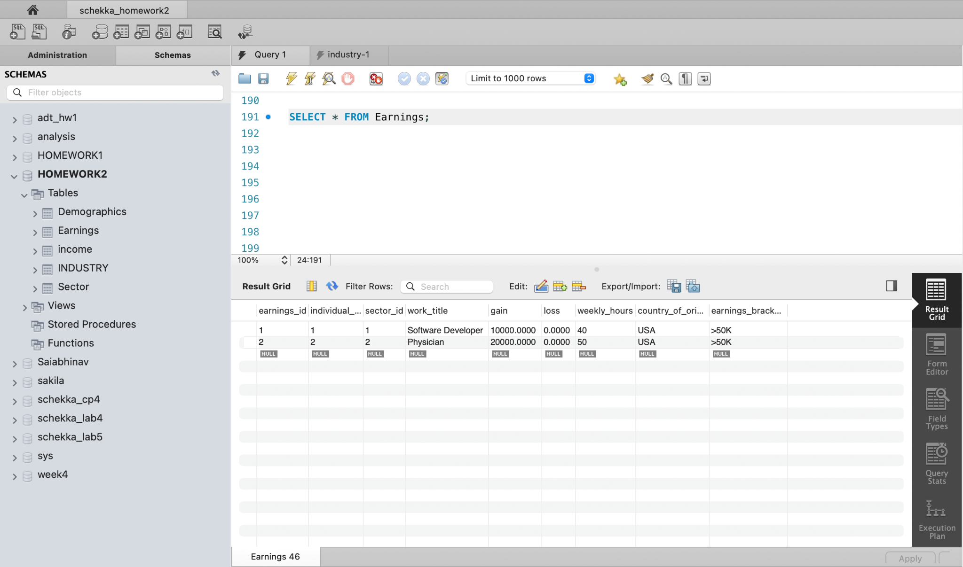

### **Part 4: Reverse Engineering and Normalization(25pts)**

#### **Question 1 (10 points)**

Draw a detailed entity-relationship diagram (ERD) representing the tables, relationships, and cardinalities. (You can use the ERD modeling tool within Workbench(Reverse Engineer) or the online diagram editor

ERD Diagram of the tables that I have created:

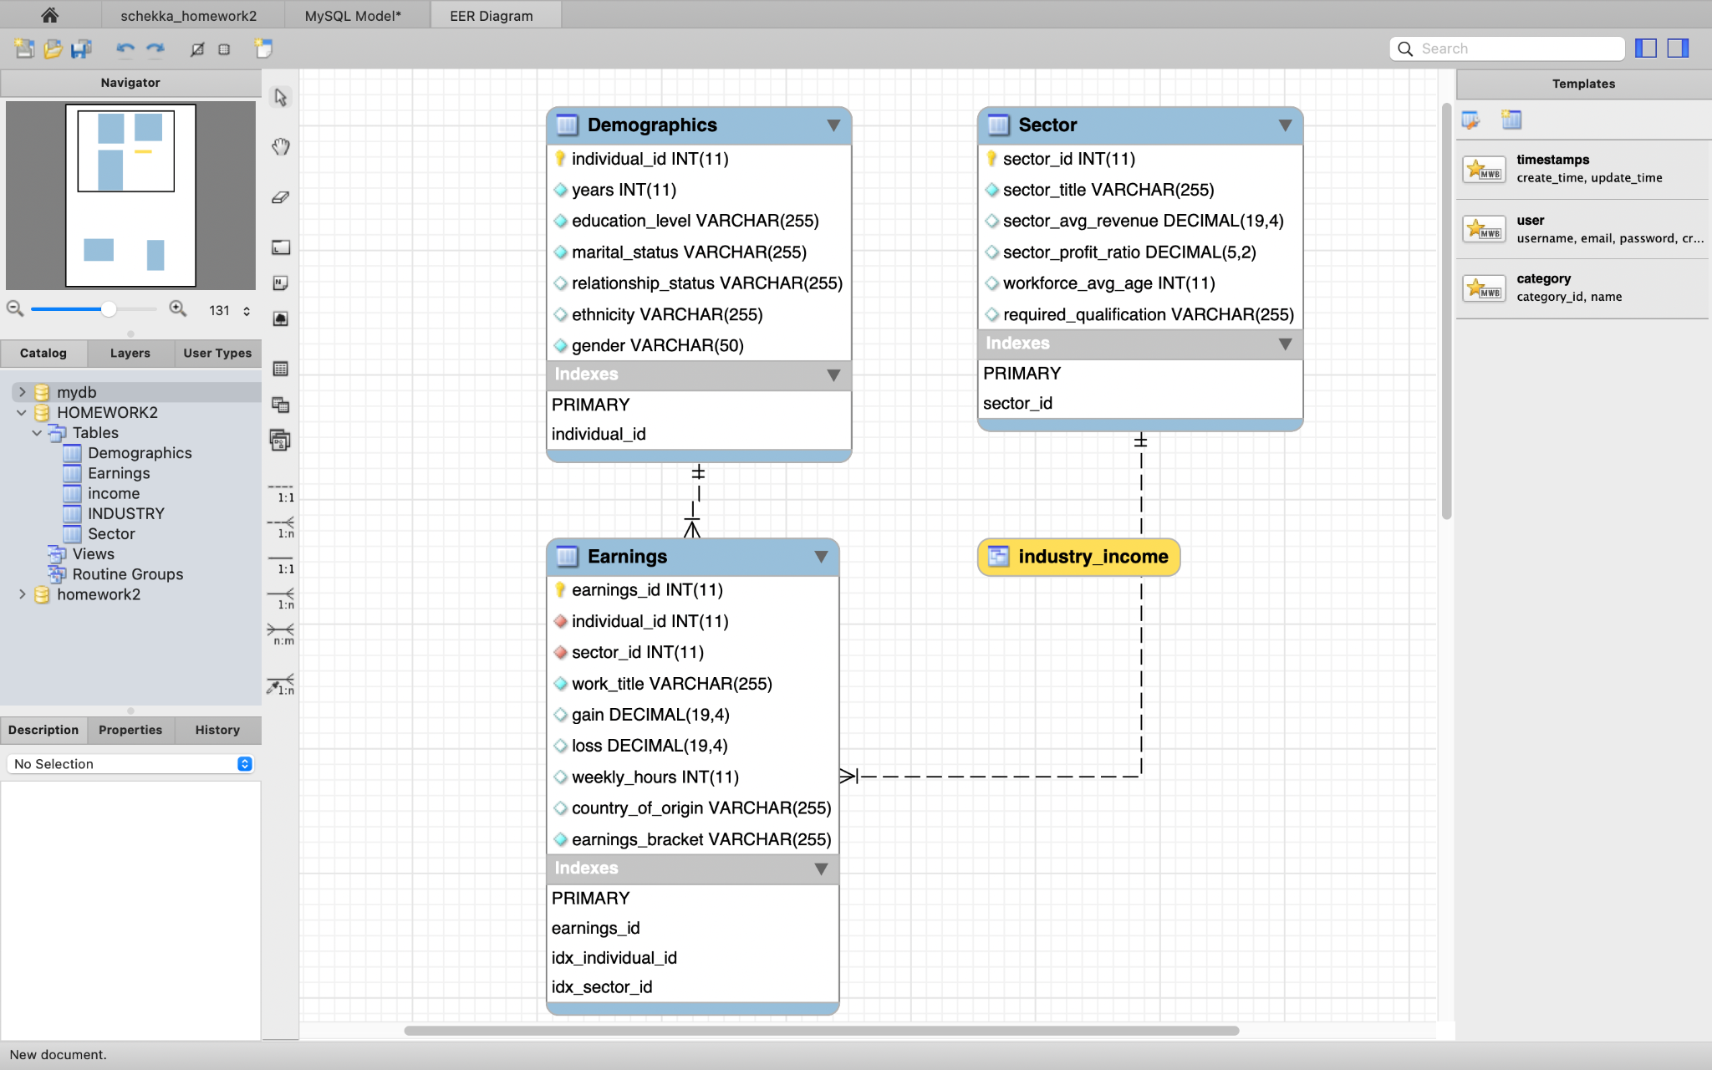

#### **Question 2 (10 points)**

Define the different normal forms (1NF, 2NF, 3NF) and Explain the benefits and challenges of achieving each level of normalization.

**1st Normal Form (1NF):**

* A table is in 1NF if it contains no repeating groups of data.
* Each column should be indivisible as far as the domain is concerned.
* Each row is unique, which often requires the implementation of a primary key.
* Columns have unique names.

Benefits:

* Ensures that the database has a basic structure that is easy to understand.
* Eliminates duplicate records, thereby reducing the amount of data.

Challenges:

* May require additional tables and relationships, which could complicate queries.
* Simply achieving 1NF does not eliminate all redundancy.

**2nd Normal Form (2NF):**

* A table is in 2NF if it is in 1NF and all non-key attributes are fully functionally dependent on the primary key.
* This means that there should be no partial dependency of any column on the primary key.

Benefits:

* Reduces the amount of redundant data.
* Makes it easier to maintain data integrity.
* Less chance of having inconsistent data.

Challenges:

* May require more complex database design and more tables.
* Can introduce more complexity into the queries needed to retrieve data.

**3rd Normal Form (3NF):**

* A table is in 3NF if it is in 2NF and all the attributes are functionally independent of each other except for the primary key.
* This means that there should be no transitive dependency for non-key attributes to ensure that each non-key attribute is dependent only on the primary key.

Benefits:

* Eliminates redundant data to a large extent.
* Reduces the possibility of data anomalies (insertion, update, and deletion anomalies).

Challenges:

* May lead to an excessive number of tables, which can make queries more complex.
* Sometimes, performance might suffer because joins across several tables may be needed to fetch data.

Since each normal form builds upon the one before it, the table must first meet the requirements for 1NF and 2NF in order to attain 3NF. Higher levels of normalization can potentially have an influence on performance, especially if the database is vast and queries may require several joins. However, they can also add complexity to the database and minimize data redundancy and improve data integrity. Finding a balance between denormalization to maximize efficiency and normalization to guarantee data integrity is the aim.

#### **Question 3 (5 points)**

**Suggest specific steps to improve our final schema by applying normalization techniques like -decomposing tables, and creating new relationships.**

**Decomposing Tables for Normalization:**

**Reviewing for 1NF (First Normal Form):** All tables appear to satisfy 1NF since each column contains atomic values, and there are no repeating groups. Each table has a primary key (individual_id, earnings_id, sector_id), which ensures that every row is unique.

**Advancing to 2NF (Second Normal Form):** Since 2NF deals with the removal of partial dependency on a composite key, I will ensure that each table that has a composite key only contains data that is dependent on the full key. However, our current schema doesn't seem to have composite primary keys, so it should already meet 2NF requirements.

**Elevating to 3NF (Third Normal Form):** For 3NF, I will remove transitive dependencies. For example, the Earnings table contains both individual_id and sector_id. If any attribute of Earnings is dependent on sector_id that is not a part of its primary key, it should be moved to the Sector table.

Additionally, the country_of_origin field in the Earnings table might be more appropriate in the Demographics table, assuming country_of_origin is an attribute of an individual, not their earnings.

**Refining Relationships:** I will review the relationships between Earnings, Demographics, and Sector. If an individual's earnings are directly related to their demographic data, a direct relationship between Demographics and Earnings should be explicitly defined, ensuring foreign key constraints are properly enforced.

I will consider whether industry_income should be connected to the Sector table, and if so, I will add a foreign key to industry_income that references sector_id. This would help in reporting average incomes by sector.

**Ensuring Referential Integrity:** I will enforce foreign key constraints where necessary. For instance, individual_id in the Earnings table should be a foreign key that references individual_id in the Demographics table. This will ensure consistency across related tables.

**Optimizing Performance:** I will create indexes on foreign key columns to speed up join operations. For example, indexing individual_id in the Earnings table will improve the performance when joining with the Demographics table.

**Removing Redundancies:** I will check for any redundant data across the tables and remove them to prevent anomalies. For instance, if sector_title in the Sector table is also contained within another table, it should be removed and referenced via the sector_id foreign key.

**Data Type Consistency:** I will verify that the data types used for foreign key fields are consistent across tables. For example, sector_id should be of the same type and size in both the Earnings and Sector tables.